Neeraj Appari T073

Wireless Sensor Networks and Mobile Communication Practical 5

Aim-Understanding, Reading and Analyzing Routing Table of a network.

Part 1-

1)Open Cisco Packet Tracer and add 2 PCs and 2 routers and connect them.

2)Click on the PC0 and give IP address and Gateway IP address.

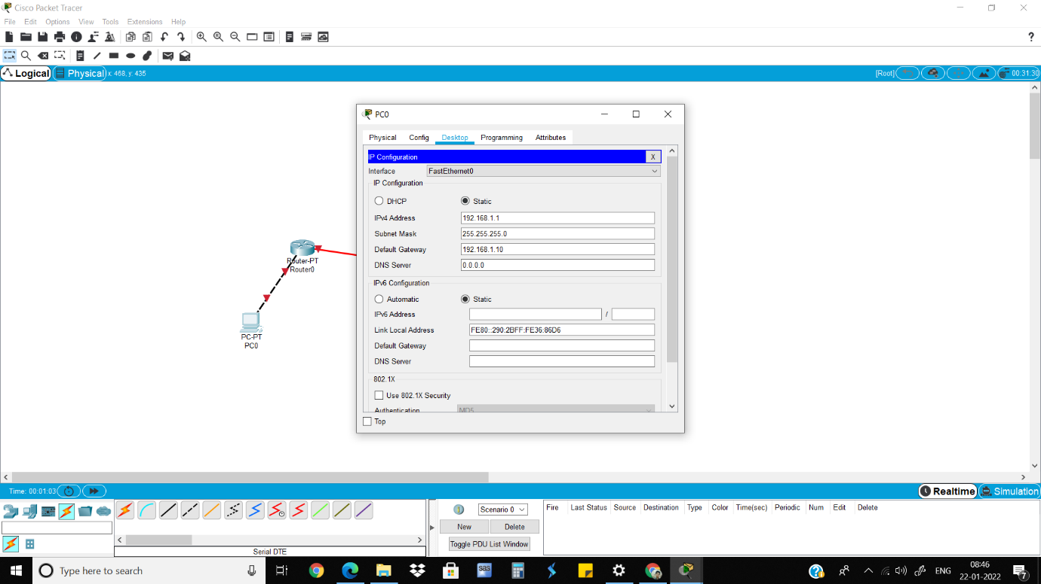

3)Click on the Router0 which is connected to PC0, turn it on and give IP address.

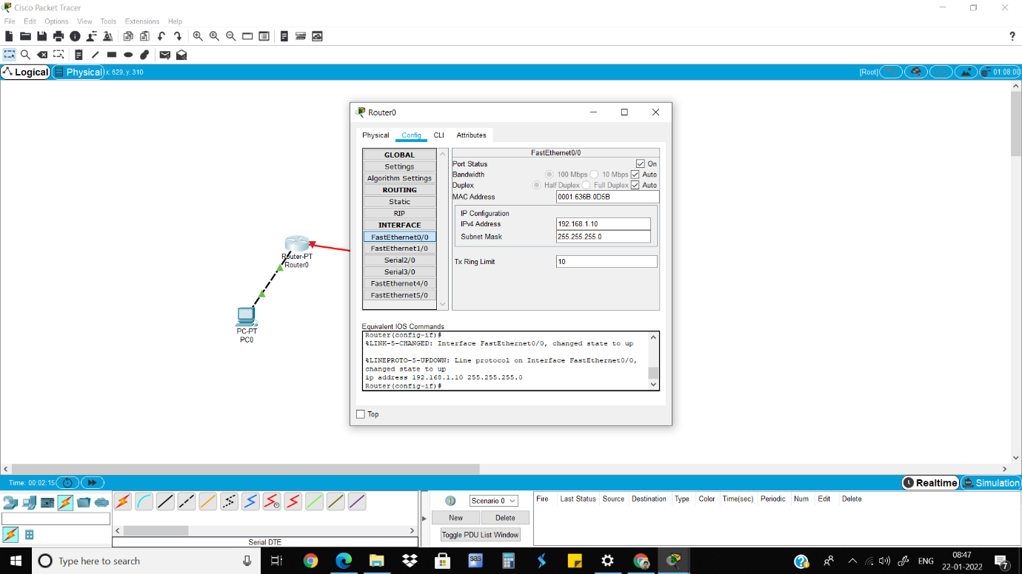

4)Go to RIP and add the gateway IP address.

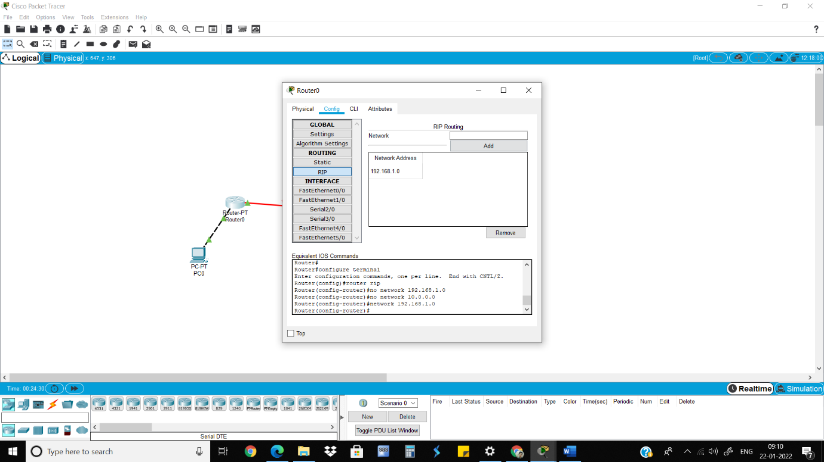

5)Do the same steps for PC2.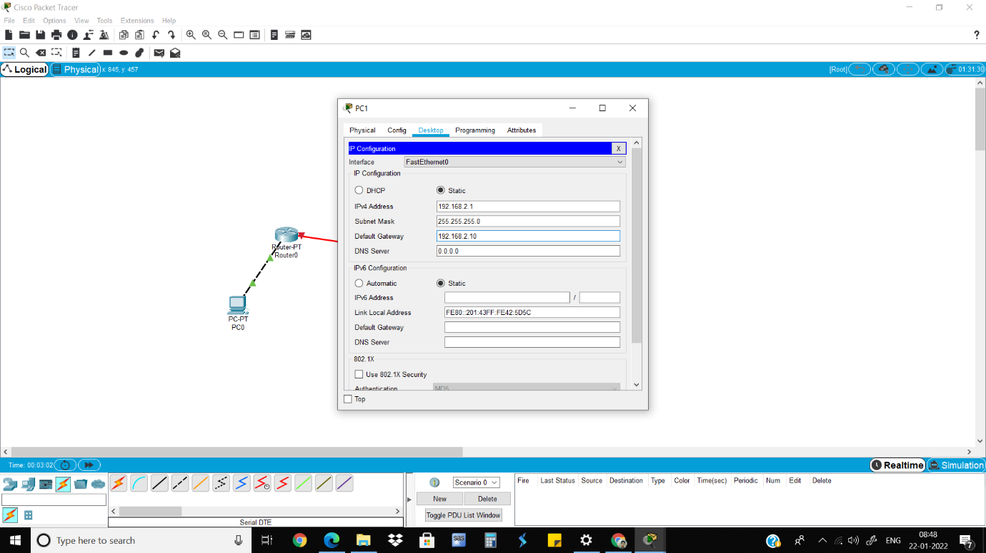

6)Do the same steps for Router1 as done in Router0.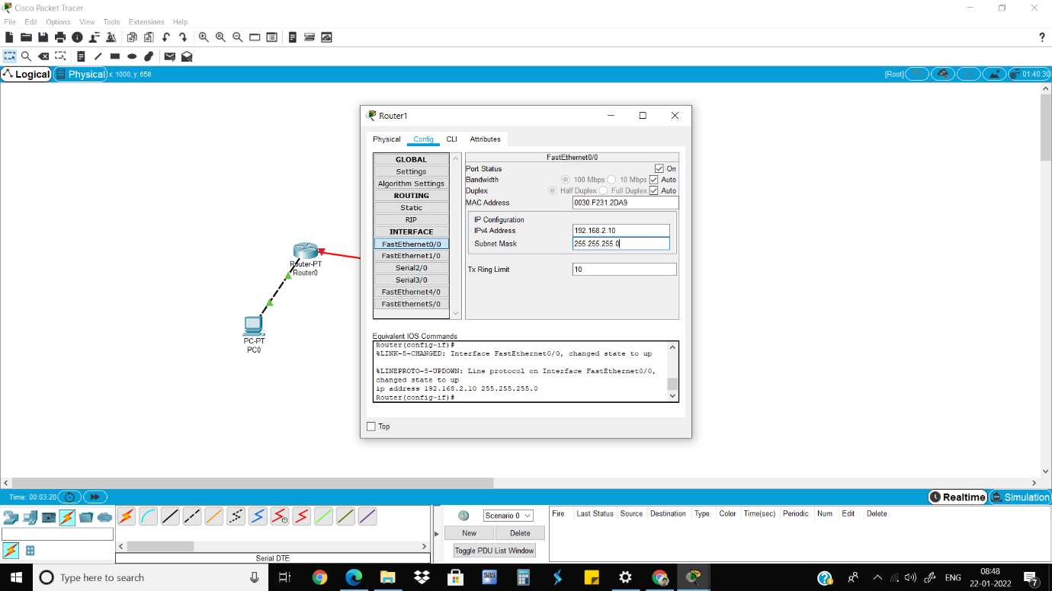

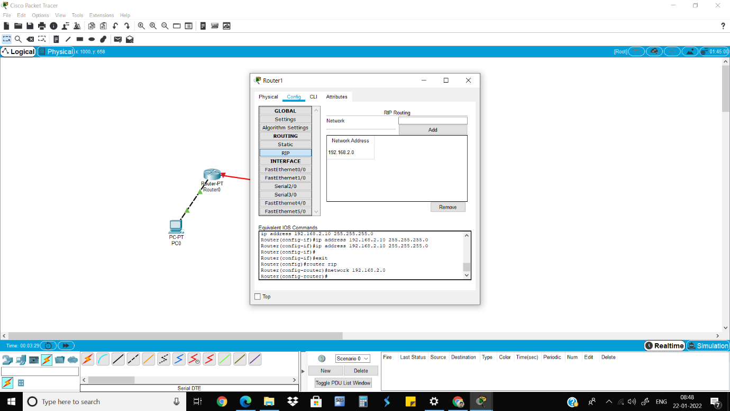

7)Go to the Serial2/0 of Router0, turn on the port, give clock rate and give the IP address.

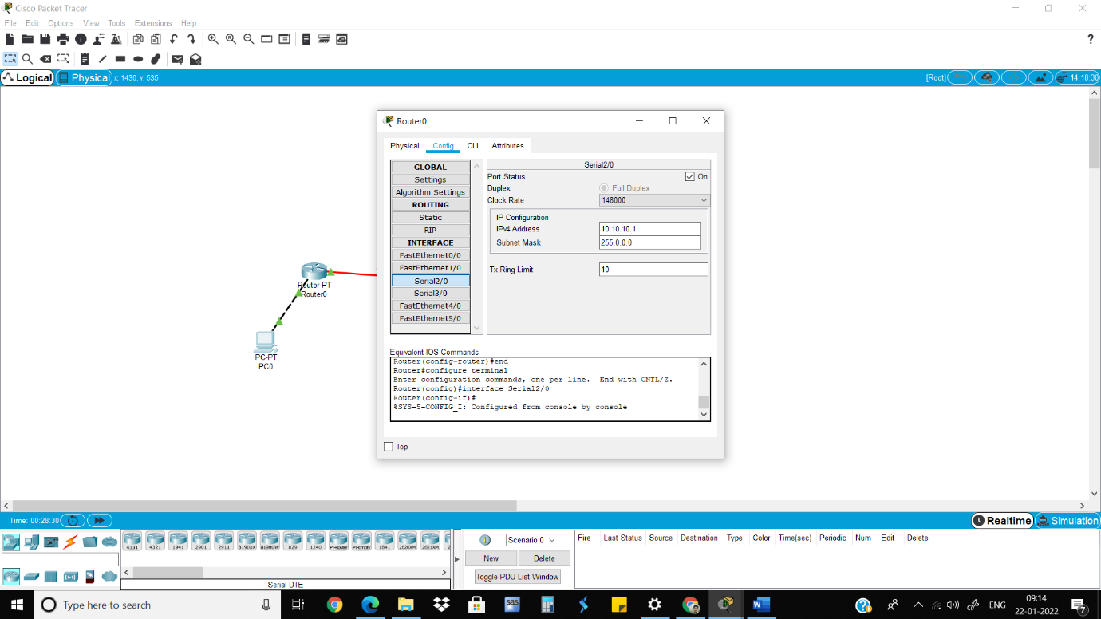

8) Go to Rip and add the IP address. 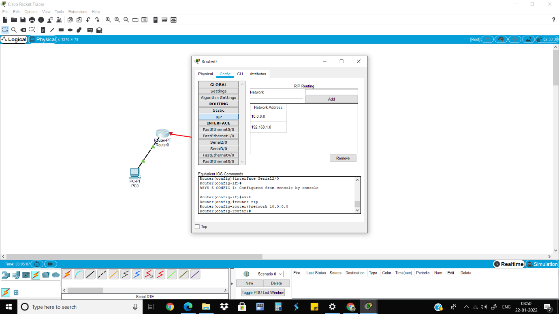

9)Do the same steps for Router1.

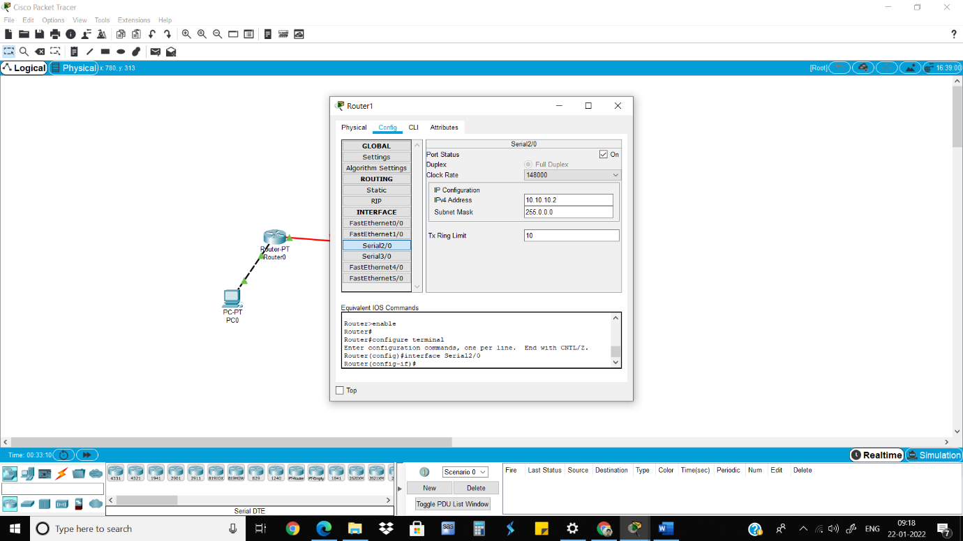

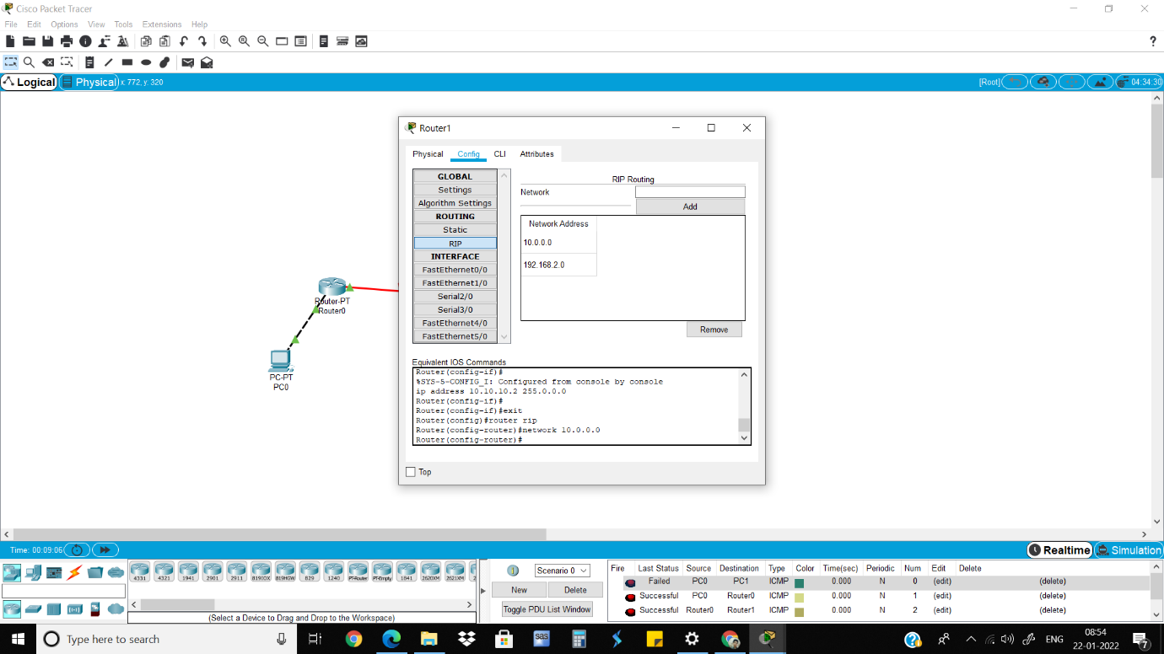

10)Send packets from PC0 to PC1 and vice versa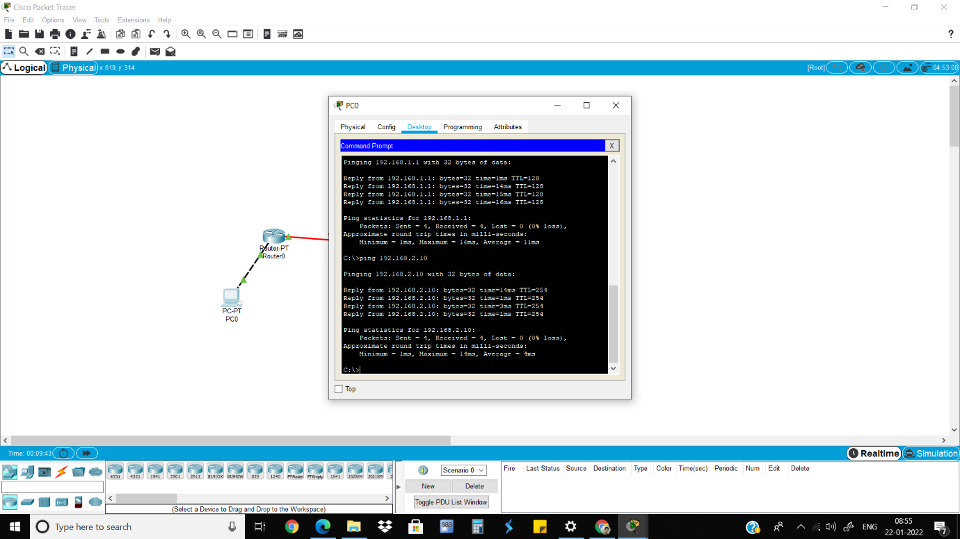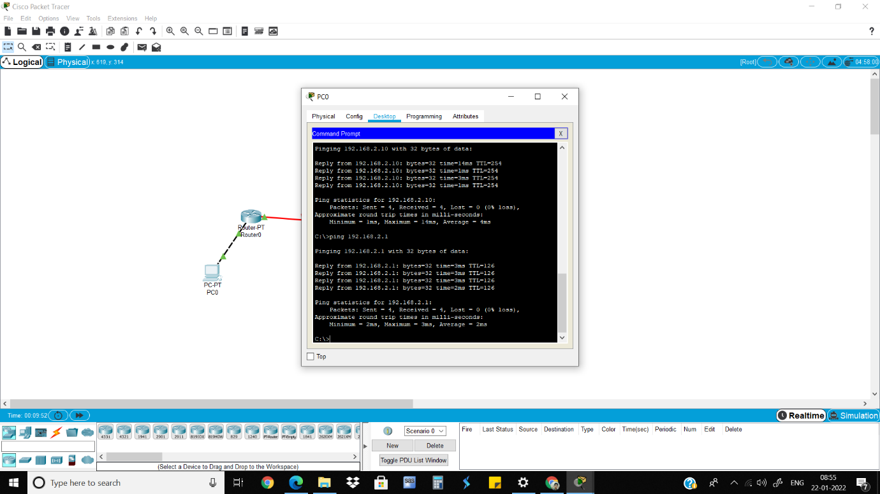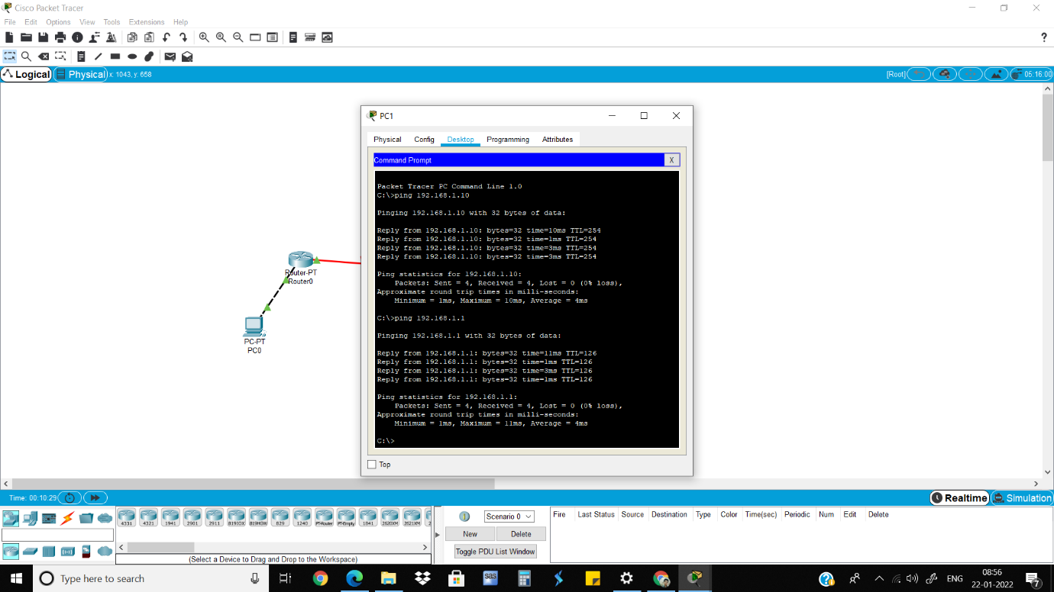

Part 2